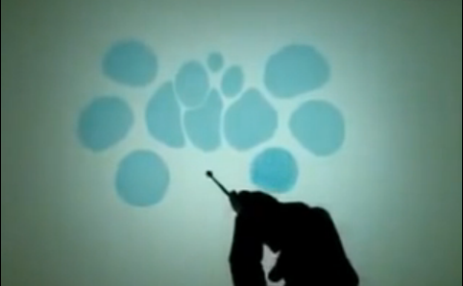
Amazing Art on Water
This Theory Friday by Aleena is just amazing. I was very interested and fascinated because this is a new whole medium that I’ve never seen before which caught my eyes.
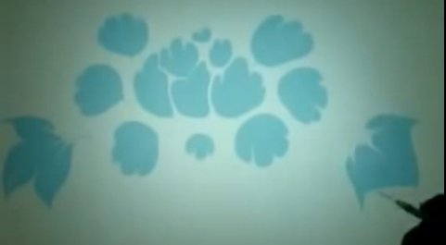

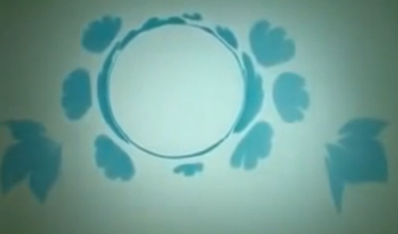
To start off with random paint blobs, by using a pointer or a pointy tip, images are created. This requires a lot of practice, skills and patients. To be able to control the paint and water takes practices.
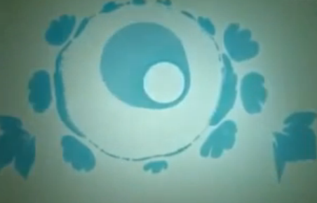
By adding drops of water, a new artwork could be developed.

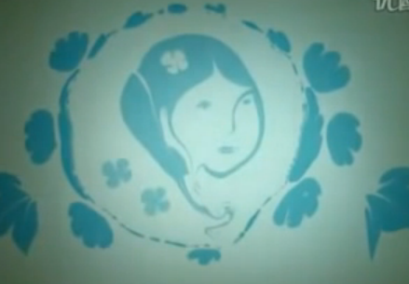
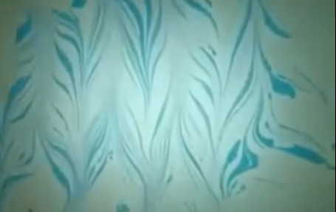
The techniques required for this kind of work is very hard but it pays off. This kind of artwork has many beautiful outcomes. To be able to control the paint and water takes practices. Even when using Watercolor on watercolor paper, it hard to control the paint as well as the water.

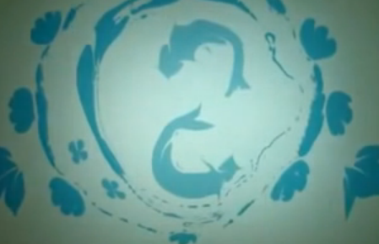
All these images started off with blobs of paint on water. By using a pointy tip, so many new art can be created

